HERITAGE ELEMENTARY
STUDENT and PARENT HANDBOOK
Policies and Procedures
2019-2020

MISSION & VISION STATEMENT
Heritage Elementary is committed to supporting the District Strategic Plan. We value Student Growth and Achievement, Empowered Employees, Safety and Security, Fiscal Responsibility, and Parent and Community Connections. At Heritage Elementary Learning First is our priority.

ATTENDANCE AND TIMELY ARRIVAL
It is the legal responsibility for parents of children under the age of 18 to have them in school daily. If a child is absent for 5 days or more, we will begin to check into the matter. Heritage teachers will begin their day of teaching promptly at 8:50. By being even a few minutes late, a student can lose the flow of the school day. Excessive tardiness will be considered an attendance issue and require that we take action.

In the event that a student displays a pattern of excessive checking in/out, absenteeism or tardiness, parents can expect the following steps to occur:

1. A referral will be made to school administration.
2. School administration will talk directly to the student and will send attendance letters to parents with a record of absences and/or tardies.
3. School administration will call/conference with the parent/guardian.
4. School administration will send a second letter with a copy to District Student Services and talk to parents/guardians to resolve attendance problems.
5. School administration will initiate Educational Neglect procedures with the District and Social Services.

Please do not bring children to school before 8:30, unless they are eating breakfast. Breakfast begins at 8:25. Children will be expected to wait outside until the first bell rings at 8:45. We certainly don’t want students waiting outside during inclement weather, or in below freezing temperatures. Administration will determine when the students can be allowed to wait indoors. There will be a sign placed on the front and back doors if they may come in early. Students can then come in and wait in the common areas until the 8:45 bell. No students may wander or enter the halls unless they have made prior arrangements with their classroom teacher.

Absences are to be verified by calling our attendance line or by sending an email.
Heritage Attendance Phone Number: 801-402-1206
Heritage Attendance Email: heritageattendance@dsdmail.net

Please note: If clicking on the email link does not work, copy and paste the email address into your email program. If your child is going to be out for an extended period time, please let your teacher know as soon as possible. Please know that we do not have the ability to stop the Davis School District call out system. If a student is marked absent, and you have asked for phone notification, the system will still call you. Be sure to remember that a note does not automatically constitute a verified absence.

Teachers must have their absences recorded in Encore by 9:20 AM (1:20 PM for PM kindergarten). Calls go out at 10:00 AM and 2:00 PM. If children come in late, they must check in at the office on the computer – that will change their absences to Late and no call will go out.

Every child who is marked absent will generate a computer call to that child's parent with the following words:

Hello, this message is from Heritage Elementary School. Our records show, <<First Name>> <<Last Name>>, was marked absent today.

This is a courtesy call and no further action is required on your part. However, if you believe your child is at school and you have received this call in error, please call Heritage at 801.402.1200 to speak with a school secretary.

To repeat this message, press the star key.

AFTER SCHOOL
Students must walk home or be picked-up promptly at the end of school and may not stay on school grounds unless they are under the supervision of a teacher or their parent. Teachers should not keep children after school without first contacting parents and making arrangements.

ATTENDANCE
Regular attendance is essential for students to learn and progress in school. Teachers are responsible to take roll and to input absences and late arrivals on the computer daily. This should be done within the first 30 minutes of class. Davis School District computer programmers have created a system that tracks student attendance and automatically sends out e-mails to parents when students have missed five days of school. If poor attendance continues, additional e-mails are sent out and meetings will be set up with parents to work on ways to fix the problems. An interesting fact is that missing school 10% of the time is all it takes to be chronically absent. That equates to about 18 days a year or just two days every month! To learn more about the dangers of missing school, please read this Deseret News article: http://national.deseretnews.com/article/2769/what-missing-class-in-kindergarten-means-for-high-school.html. A student who is absent 10 consecutive days with no communication from parents or guardians may be taken off school records.

- First Warning: Administrative meeting with student; email/phone call to parents.
- Second Warning: Administrative meeting with student; letter to parents.
- Third Warning: Administrative meeting with student; letter to parents and administrative
conference.
- Fourth Warning: Administrative meeting with student; referral to DSD Student
Service/juvenile court

ABSENTEE LETTERS
Absentee letters – will be sent home for those who have been absent 10% of the days that school has been in session. Teachers will communicate with the secretaries and principal about their absentee concerns.

BEHAVIOR MANAGEMENT
At Heritage Elementary we try to encourage and celebrate the positive behavior of our students. We believe that elementary school is where students really start to learn the importance of being a socially responsible citizen in a community setting. There are several school wide programs that help teach students about life skills and the 7 Habits of Happy Children to help support behaviors of being a good citizen. Our guidance counselor also teaches Mindfulness lessons which are supported by the teachers.

Character Education: Character education opportunities are provided by classroom teachers daily and the school counselor visits classrooms with a life skill lesson bi-monthly. At Heritage we have a dedicated staff of individuals who want to help students be successful both academically and socially.

DISCIPLINE AND STUDENT CONDUCT – DISTRICT POLICY
https://www.davis.k12.ut.us/district/administration/policy-manual/section-5-student-services

DISCIPLINE PLAN – SCHOOL
Principles
All students are instructed to be responsible, respectful, and safe by our teachers, school counselor, and the administration at the beginning of each school year. This follows the Positive Behavior Intervention and Supports which is a systemic approach to proactive, school wide behavior based on a Response to Intervention model which can increase academic performance, improve safety, decrease problem behavior and enhance the positive school culture already in place at Heritage.

Every person deserves to be respected, to feel safe, and be free from danger. Learning is enhanced in a safe environment. Learning is also enhanced by the establishment of academic and behavioral expectations. Students will be expected to conduct themselves in respectful and responsible ways. Special emphasis will be placed on the teaching of self-discipline, good citizenship and social skills.

Federal law makes it illegal for school personnel or parents/guardians to share personal information regarding other children. Parents will only be given pertinent information of the actions of their child. The school will protect the confidentiality of all parties involved.

Life Skills and 7 Habits
We teach skills that will help our students develop behaviors that will help them grow into responsible, successful people. Along with these skills, students are instructed in how to recognize and use expected behaviors (politeness, friendliness, sharing, caring, etc.) in their day to day dealings. We also teach them how to deal with the unexpected behaviors (mean words, harassment, exclusion, etc.) of others that they all face. The Life Skills are: friendship, effort, pride, cooperation, responsibility, perseverance, caring, integrity, problem solving, and patience. The 7 Habits are: Be Proactive, Begin with the End in Mind, Put First Things First, Think Win-Win, Seek First to Understand, Then to be Understood, Synergize, Sharpen the Saw. Our school counselor and administration will teach lessons in classrooms to support these skills and habits. The teachers review what they look like and watches for students exhibiting them throughout the week. Our counselor will also be teaching Mindfulness lessons in each class.

Discipline Plan
We have a school wide discipline plan of interventions to help us improve the way our students treat one another. We would like our school to have zero tolerance for hurtful behavior.

Students will have the chance to earn a Paw Print for positive behavior from any adult employee at the school. These tickets can be deposited in designated containers in their classrooms and the office. Drawings will take place on Fridays.

There will be consequences for inappropriate behavior. Inappropriate behavior will be defined as anytime a student is exposed, repeatedly and over time, to negative and hurtful actions on the part of one or more students. This behavior could be physical, verbal, or nonverbal. If a student is showing support for the bullying, they will experience the same consequence as the student doing the bullying. We want the bystander students to become involved in stopping the inappropriate behavior.

The consequences are separated into 4 levels. The level each student is at will be determined by the classroom teacher.

- At Level 1 the teacher will handle the situation and help the student form a plan to stop the behavior.
- At Level 2 the student will be sent to another prearranged classroom and the parent will be contacted.
- At Level 3 there will be a meeting with the student, the teacher, the parent, and the principal.
- At Level 4 there will be suspension either at home or at another school.

Each teacher has a buddy classroom where students who need a break from their surroundings can go to be supervised. They are sent to the buddy classroom typically for misbehavior. A buddy teacher is chosen from a different grade level and with enough time distance to provide a place for a student to go during his or her regular teacher’s lunch time.

Bullying and Harassment
Verbal aggression such as name-calling or verbal threats, physical or verbal intimidation, retaliatory aggression including rumor spreading, intimidation, enlisting friends to hurt another child or engaging in social isolation of other students are considered inappropriate. Harassment specifically includes the repeated bullying of other students.

Consequences: Teachers will meet with students on an individual basis to help victims of bullying and harassment. Teachers will communicate with parents. Teachers will suspend recess privileges of those students who bully or harass other students. Continued issues of bullying and harassment will be referred to the administration. See school discipline plan above.

Students are expected to make good decisions by following the procedures to protect themselves in any bullying/harassing situation. Students who fail to follow these procedures when harassed and strike back/retaliate at an aggressive student by injuring that student are in violation of school/district policy.

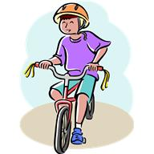
BICYCLES/SKATEBOARDS/SCOOTERS
Students can ride their bicycles, skateboards, and scooters to school when:
- A parent has given permission.
- All safety rules are followed, including obeying the crosswalk attendant and wearing helmets.
- They are walked, not ridden on school grounds.
- They are locked in the bike rack.
- All bikes, scooters, and skateboards should be labeled with the owners’ names.

Due to safety and fire code, scooters will not be allowed in the building.

BIRTHDAY TABLE
To celebrate a child's special occasion, a "Birthday Table" will be provided by our PTA at lunchtime for grades 1 - 6 one day each month.

BREAKFAST
Breakfast is served every school day for those students who pay for it. We begin serving at 8:25 AM and finish by 8:45 AM so as not to encroach on class instruction time.

CALENDAR – District
https://resources.finalsite.net/images/v1564529607/davisk12utus/hl9hjbmla4rgyz1j20zo/Traditional19-20.pdf

CALENDAR – School
A school calendar is located on our school’s web page. https://heritage.davis.k12.ut.us/parents-students/school-calendar . This calendar is updated regularly. Parents should check the calendar often to gain information of upcoming school activities.

CELL PHONE POLICY
Students may use electronic devices brought from home before the first bell and after the final bell of the school day. Use of these devices during the school day, including lunch and recess time, will not be allowed. Devices must be completely powered down, turned off and kept out of sight.

Confiscation
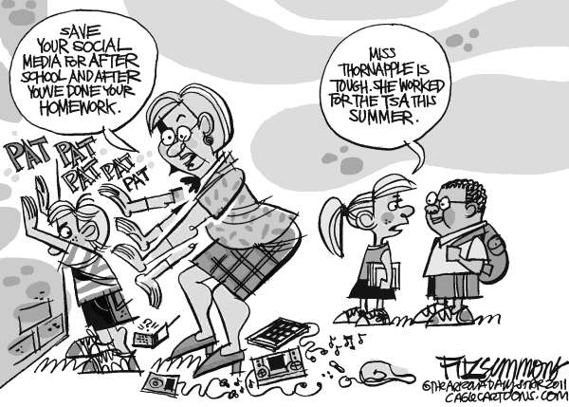
If a student violates this policy, his/her electronic device may be confiscated. When an employee confiscates an electronic device under this policy, he/she shall take reasonable measures to label and secure the device and turn the device over to a school administrator as soon as the employee's duties permit.

The electronic device will be released/returned to the student's parent or guardian after the student has complied with any other disciplinary consequence that is imposed.
- 1st offence – the device is returned to the student after school with a warning from the teacher.
- 2nd offence – the device should be brought to the office and can only be picked up by the parent. An administrator will make the parent notification.
- 3rd offence – the student may no longer bring an electronic device to school. The device should be brought to the office and can only be picked up by the parent. An administrator will make the parent notification.

CHECKING OUT STUDENTS
Anyone picking up a child must do so through the office. They must show a photo ID and be listed on the child's information sheet. Parents should never go to a classroom or the playground to pick up their children. Teachers will not allow parents to pick up a student from a classroom.

CHECKING IN STUDENTS
Check-in at the office is required for all students who enter the school after 8:50 AM.

CLOSED CAMPUS
Closed campus means students are not to leave the school grounds during the school day without clearance from the office and parental contact.

COMMUNICATION – Parents
Communication between parents and school staff is also of vital importance. Teachers will be sending home at least a monthly calendar or newsletter. Good communication is vital in order to make and keep positive home and school relationships. Please communicate with your child’s teacher as soon as you see something that concerns you so that any misunderstandings can be cleared up.
DAILY SCHEDULES
Breakfast (students should use the front doors) …………………………………………8:25 - 8:45
1st bell………………………..……………………………………………………………..…………….8:45
Tardy bell………………………………………………………………………………………….…………….8:50
Monday – Thursday………………………………………………………………..…………...8:45 - 3:25
Friday (Early Out)………………………..………………………………………..…………….8:45 - 1:25

Lunch Schedule

Lunch Time | Grade |  | End of Recess
11:30 | 1st, 1st | Liu, Taylor | 12:10
11:35 | 1st, 1st | Schneider, J Johnson | 12:15
11:40 | 2nd, 2nd | Anderson, Sweat | 12:20
11:45 | 2nd, 2nd | Hales, Liu | 12:25
11:50 | 2nd, 3rd | Jensen, B Johnson | 12:30
11:55 | 3rd, 3rd | Bland/Carmack, Stanley | 12:35
12:00 | 3rd, 3rd | Wilson, Xie | 12:40
12:05 | BREAK | NO CLASSES
12:10 | ¾ Split | Phillips | 12:50
12:15 | 4th, 4th | Hansen, Young | 12:55
12:20 | 4th, 4th | Elswood, Yu | 1:00
12:25 | 5th, 5th | Li, Miller | 1:05
12:30 | 5th, 5th | Cowley, Hyatt | 1:10
12:35 | 6Th, 6th | Tate, Tian | 1:15
12:40 | 6th, 6th, 6th | Hansen, Lawson, Weber | 1:20

Recess Schedule

10:30 – 10:45 | Kindergarten | 2:00 – 2:15 | 1st and 2nd
10:45 - 10:55 | 1st and 2nd | 2:15 – 2:30 | 3rd, 6th, Phillips and Kindergarten
10:55 – 11:05 | 3rd and 6th | 2:30 – 2:45 | 4th and 5th
11:05 – 11:15 | 4th, 5th and Phillips

KINDERGARTEN SCHEDULE
Monday - Thursday
A.M………………………………………………………………………………………..8:45 - 11:30
P.M………………………………………………………………………………………..12:45 - 3:25

Friday
A.M………………………………………………………………………………………..8:45 - 10:50
P.M………………………………………………………………………………………..11:25 - 1:25

DAVIS READS
https://www.davis.k12.ut.us/academics/library/library

We support and participate in the Davis Reads initiative. "Davis Reads" is a countywide effort that engages schools, libraries, cities, and businesses in the passionate endeavor of weaving the joy and the ability to read through the fiber of each of our citizens.

DRESS CODE – STUDENT AND ADULTS
Clothing must cover areas from one armpit across to the other. Tops must have shoulder straps, no spaghetti straps or wide openings in the armpit. Shorts and skirts need to adequately cover all underclothing adequately. Shoes must always be worn and should be safe for the school environment. (Pajamas, bedroom shoes or slippers shall not be worn, except for during school activities approved by the principal.) Proper shoes must be worn during PE classes. Head gear including hats, hoodies and caps are not allowed unless permitted for religious, medical or other reasons by school administration. Clothing may not depict, imply, advertise, or advocate illegal, violent, or lewd conduct, weapons, or the use of alcohol, tobacco, or drugs. Clothing may not display or imply vulgar, discriminatory, or obscene language or images.

Please remember that proper attire can positively influence the way children academically and behaviorally approach their school days.

Please make certain that your children are dressed appropriately for the weather conditions. With few exceptions, students will need to be dressed so they can go outdoors during recess and lunch times. On exceptionally cold or stormy days, students will be allowed to stay indoors.

DRIVERS AND STUDENT SAFETY
After a comprehensive review from all vested parties, the following rules were established to keep your children, you, and the entire Heritage community safe. Student safety is a high priority at Heritage. Drivers should exercise caution near and at the school. Please be aware of and inform anyone who might be driving students to school (grandparents, siblings, babysitters) of the following safety precautions:

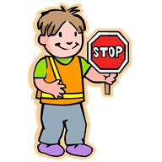
Red zones are for emergency vehicle access and must always be kept clear.
Drop-off curbs are only for student drop-off and pick up. Do not leave cars unattended in these areas. Parking is not allowed on the red curb on Arbor Street. It is now just a drop off lane.

Heritage Elementary - a community school designed for walking
For the safety of the children, groups are best! Encourage your children to stay in groups as they walk to and from school.

Drop-off/Pick-up Zones
Properly utilizing the drop-off/pick-up zones will keep everyone safe and traffic flowing. Please pull forward if there is a space in front of you. Please DO NOT call to your student to run through the drop-off zone to where you are in the drive-thru lane.

FOUR drop-off zones
- In front of the school.
- On Arbor Lane.
- North drop-off by the portables
- South drop-off on Weaver Lane

Bus Parking:
The bus will park next to the curb on the east end of the south drop-off lane.

Car Parking:
If you need to leave your car for any reason, please make sure it is in a marked parking stall. Do not use the accessible parking stalls (blue and white markings) unless you have the appropriate license plate or placard. Parking is not allowed along the curbs that are painted red.

Stay in your car:
Always stay in your car if you are next to the curb. If you need to come into the building, please park in a marked stall and walk in using a crosswalk. Drivers please be aware of children in the crosswalk. Children should exit the vehicle from the right passenger side only. Drop off on the right, pass on the left.

Late Drop off:
If your children are late, please drop them off in front of the building and have them come to the office to check in. If your kindergarten students are late, please come park in the parking stalls in the front of the building and bring them to the office to check in. Please do not knock on the kindergarten doors/windows to be let in.

North Drop-Area:
There is only one place to drop off students this year in the north parking lot. You will come in from Arbor and then circle around. Students will be dropped off by the teacher on the east side. As your student gets out, the next car will move into that place and let their children out. There will be NO LEFT TURN onto Arbor during drop off and pick up times.

Crosswalk Safety:
Students must use crosswalks to cross busy streets. Please speak with your children about the following crosswalk safety rules:
- Do not go into a parking lot without a parent (or adult) escort.
- Do not cross a crosswalk until you have: 1) gotten off your bike, scooter, or skateboard. 2) Looked both ways. 3) Waited for cars to stop

Reminders
- Turn off cell phones and drive slowly in school zones.
- Watch for children in crosswalks.
- Be considerate of other drivers.
- Park in designated stalls only.

EMERGENCY DRILLS AND PROCEDURES
To be prepared for an emergency, various drills will be held throughout the year. Fire drills are held every other month. Other drills include earthquake, lock down, lock out and possibly an evacuation drill during the year. In the event of an emergency, parents will be notified using the District Call Out System, when possible.

"Lock down" or "lock out" procedures will be used if there is an unsafe situation outside or inside the building. If the problem is outside of the building, all outside doors will be locked and no one will be allowed to enter or leave the building until clearance is given by law enforcement authorities. Students and teachers will go about business as usual. If the threat is inside the building, students will remain inside locked classrooms under the calm supervision of teachers until notified otherwise by authorities. In the event of a fire, the building is evacuated to the north west area of the playground where all students will be accounted for and supervised by their teachers.

Parents may check out their students upon presenting the proper documentation. For the safety of your child we request that each student have emergency release information on their registration card. This card will specify who you will allow to pick up your child in case of an emergency. If these instructions change during the year, please notify the office. Because of limited parking, it is our goal for students to be picked up in neighborhood groups rather than having all parents pick up their own children.

In the case of an emergency, you should receive a call via the District Call out system.

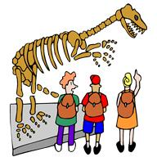
FIELD TRIPS
Field trips are a great way to reinforce and reteach concepts from the core curriculum. The school and PTA will pay for buses for students at each grade level to go on one field trip per year school. Admission costs are collected through donations from the grade level student body and/or donations from the parents in the community. Teachers may ask parents for a donation to cover admission costs, but they may not assess fees. Every child will be able to attend the field trip regardless of the ability to donate. Also, parents must sign permission slips for their children to participate in any field trip. Additional field trips may be scheduled that are at no cost to the school.

GRADES
Grade reports are sent home 4 times per year at the end of each term. Teachers may send grade reports home more often if needed. Whenever questions arise on grades, students and parents are to contact the teacher promptly. The office personnel do not have access teachers’ records and will not be able to answer questions about them. When questions do arise, or whenever a progress report is desired, please contact your child’s teacher to discuss concerns. Teachers will make every effort to contact parents when concerns with a student’s academic and/or citizenship grade occur. Parents are also encouraged to make every effort to monitor their student’s education. Parents are responsible to check with teachers if they have questions on grades and/or behavior.

HALLWAY BEHAVIOR
BEFORE SCHOOL - Students should not be in the building before school or during recess times. Teachers have the responsibility of monitoring their hallway areas for students who may have forgotten the rules.
DURING THE DAY – While the class is moving through the hallways, students should walk, without talking, in a single file line. A teacher should always be present when their students are moving through hallways.
HOMEWORK
https://resources.finalsite.net/images/v1525455000/davisk12utus/aoymyzhfifdanz0dhxxm/HomeworkGuidelinesSept2017.pdf

Homework is an important way to reinforce and practice what is learned in school. Teachers should give meaningful homework assignments in accordance with the following suggested guidelines:

1st grade - 10 minutes
2nd grade - 20 minutes
3rd grade - 30 minutes
4th grade 40 minutes
5th grade 50 minutes
6th grade 60 minutes

When warranted by special projects or difficult curriculum, teachers may give longer homework assignments on occasion. Homework for students with disabilities or special circumstances should be determined on an individual basis and should not be at a level above their capacity to create frustration or undue stress for them or their parents. Only appropriate assignments should be sent home as homework.

LOST AND FOUND
Our school’s lost and found is in the boxes by the gym. Items will be placed on tables during parent/student/teacher conferences for parents to go through. Please label coats, jackets, sweaters, etc., so that items can be returned to your children. Please encourage your children to keep track of their jackets, coats, other items of clothing, and books, etc. The box really fills up quickly at times. Parents are always welcome to check for missing items as well. There is no need to wait until parent/student/teacher conference weeks.

LUNCH ACCOUNTS
Menus can be accessed online at https://davis.nutrislice.com/menu/menus-eula . Money for student meals may be paid through your myDSD guardian account. Good manners are expected in the lunchroom and are monitored by a lunchroom supervisor. The very few students whose behavior is inconsistent with good manners, may lose lunchroom privileges for a time.

LUNCH PRICES
https://www.davis.k12.ut.us/departments/nutrition-services/school-meal-prices-payments-refunds

Parents may go to the nutrition services website for menus, prices and more information about school lunch.
$1.85 Elementary Lunch. Reduced priced lunch $.40
$1.35 Elementary Breakfast. Reduced priced breakfast $.30
Adult Lunch $3.40
Adult Breakfast $2.00

MAKE-UP WORK
Make-up work (when a child is absent) will be available when the child returns to school. In the case of an extended illness, parents should contact the school to see if the child might qualify for home tutoring services. Teachers may also gather homework to be sent home with another student when requested. Parents should not ask teachers to prepare assignments in advance before a planned absence. Make-up work will be available upon the student's return. Parents are responsible for assisting students in completing work missed due to vacations or outings. Bear in mind that there is a wealth of learning at school that does not involve paper and pencil. Class activities and discussion cannot be reproduced or re-staged for students who are absent.

MATURATION Program
The maturation program will be presented to our 5th grade students. Parental permission slips must be signed and on file for each student participating. The presentations are available on the DSD website and will be shown during the program with parents present. https://www.davis.k12.ut.us/academics/physical-education/elementary

MEDICATION
If a student has prescription medicine to be taken during the school day, the medicine must be labeled, in the original pharmacy container, and be kept in the office. A form signed by your doctor is also required to be filled out and on file at Heritage before any medication can be dispensed. The above procedures are designed to help ensure students receive the appropriate medication and dosage.

If a parent decides that their student is mature enough to administer a medication his or herself, and keep it safe from other students, he or she may do so. It is important that only one day’s worth of medication is sent to school if this is your decision. All responsibility then rests with the parent. We would appreciate a note to the teacher stating this decision.

If a child has asthma and uses an inhaler, the child may personally carry their inhaler. Please note that a health plan is required on file if an inhaler is needed.

As per Health Department regulations, staff may not distribute nonprescription medication to students. (i.e., Tylenol, cough syrup, etc.)

MORNING SUPERVISION OF STUDENTS
We have limited supervision of children on the playground before and after school. A staff member will be monitoring traffic to keep students safe as they cross the road to sidewalk in the front of the school. As you drop off your children for school, please be mindful of the students, other cars, and the special education bus.

MyDSD ACCOUNT
We highly recommend that all guardians set up a my.DSD guardian account. https://mydsd.davis.k12.ut.us/Account/Login?ReturnUrl=%2f
The benefits include:
Checking your student's grades/missing assignments
Making payments on lunch accounts
Scheduling SEP conferences
Taking Teacher Surveys online
Looking at test scores
Viewing attendance
Paying for yearbooks, fines, and registration
...and much more

Notice of Non-Discrimination & District Policies
Most of the Heritage’ school policies are included in this Student Handbook and a document entitled District Policies and Procedures which is located on our school’s web page at:
https://davisk12utus.finalsite.com/district/administration/policy-manual/section-5-student-services

OFFICE HOURS
The office is open on school days from 8:15 a.m. to 4:00 p.m. Parents must make every effort to see that their child(ren) either walk home or are picked up immediately after school. Students cannot be left at school beyond 3:45 PM as there is no adult supervision for them.

PARENT/TECHER/STUDENT CONFERENCES
Parent/Teacher/Student Conferences will be held in November and January. Students are an important part of these conferences and will enjoy attending as teachers praise their growth and set goals for the coming term.

PE POLICY
Students should dress appropriately for safe participation in P.E. Teachers will review the expectations of each student during their PE time. The expectations are:
- Footwear should be rubber-soled shoes which are appropriate for physical activity. For safety reasons we ask that student refrain from wearing sandals, flip flops, clogs, platform/high heels, open toed and plastic bottomed shoes, snow boots or other footwear that would be unsafe in PE situations.
- If girls wear dresses, they should wear shorts underneath.
- Students should participate with enthusiasm.
- Students are responsible for their actions and are expected to make good choices.
- Students should use appropriate language, show respect for self, others, equipment and property.
- There will be an alternative activity for those that cannot participate in the activity for that day due to injury or illness.

PHONES –CLASSROOM
The office may direct a call to a classroom during the school day or a parent may call the classroom phone directly. Teachers will not answer phone calls during classroom instruction. However, they will check voice message after school and during their breaks.

PROFESSIONAL DEVELOPMENT DAYS
There are four professional development days scheduled for teachers to work. Students do not attend school on these days. The 2019-2020 days are scheduled for September 23, 2019, November 1, 2019, January 23, 2020 and March 23, 2020.

PRIVACY – STUDENT INFORMATION
FERPA – Family Educational Rights and Privacy Act. This act requires educators to be very careful when sharing information about students. Teachers can only share information about a student with the student’s legal guardian. If the grandparent is the guardian – then we can share information freely.

Additionally, we cannot give information to parents about other students – not even their names. A parent may report that another student is harassing their child – they can even provide the name; that is appropriate and very helpful. However, we cannot share back information about the other student such as “yes – he has troubles with others as well” or outline the consequences that child will be given. It is somewhat tricky, and parents certainly want to know the consequences applied of someone who has injured their child, but we are under legal obligation when discussing students.
PTA
The PTA (Parent Teacher Association) at Heritage Elementary is a viable, involved organization that seeks to benefit the education, safety, and welfare of our students. They work hard to provide programs and activities for the students to achieve this. Some of the programs and activities offered by our PTA are: field trip transportation, Reflections, Walk to School Safely Day, Red & Green Ribbon Weeks, book fairs, reading month, teacher appreciation week, teacher appreciation dinners, family picnic and chalk night, birthday table, field day, and much more.

RECESS
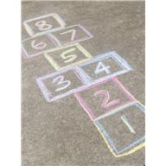
Please see the school schedule listed earlier in this document. All students will line up at the end of recess before they come into the building. Teachers should pick students up outside and escort them into the building at the end of each recess.

RECESS - INSIDE BREAK
During inclement weather an “Inside Break” will be called. The building administration will make that call. The break will give students time to use the restroom, get drinks, and take a short break from their classwork; however, it is not a time to play as they would outdoors. Quiet activities such as games and reading will be conducted. During an inside break teacher will supervise their students inside their classrooms.

RED AIR DAYS
We continually monitor the quality of air in accordance with district policy. Some or all students may need to stay inside the school building during red air days. When air quality is a problem, the office staff will make an announcement over the PA system before our recess times.

RESTROOM POLICY – CLASSROOM
Teacher restroom rules will be included in the class disclosure that is provided for parents and students at the beginning of the school year. Some students may have physical issues that require frequent restroom breaks. All students must feel free to use the restroom without undo repercussions.

SEM - SCHOOL WIDE ENRICHMENT MODEL
Services for students needing academic enrichment are available through the School wide Enrichment Model (S.E.M.). Students are placed in this pull-program on recommendation of their teachers and the student’s grades, based on the following criteria:
- Above average ability
- Task commitment
- Creativity
- Leadership

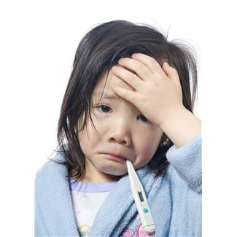
SICK CHILDREN/ROOM
If a child reports being sick while at school, the teacher will use his or her discretion to decide whether to send that child to the office to lie down in the sick room. The office staff is trained to take care of all issues regarding sick/injured students. The sick room is available on a temporary basis for those students who are sick until a parent is contacted.

SECURITY – BUILDING
All teachers are instructed to keep their classroom doors locked during the school day. This will provide a much higher level of security and safety for teachers and students. We follow the mandated security protocols dictated by Davis School District and the Layton Police Department.

SEVERE WEATHER
In the event of severe inclement weather, there will be a sign posted on the front doors telling students to come inside. Students will be allowed to wait in the common areas before school if the weather is extreme.

SNOWBALLS
Throwing snow of any form is not allowed at any time on the playground. This includes before, during and after school. Snowballs should not be thrown on the way to or from school either.

STRATEGIC PLAN
https://www.davis.k12.ut.us/district/strategic-plan-for-excellence-in-education

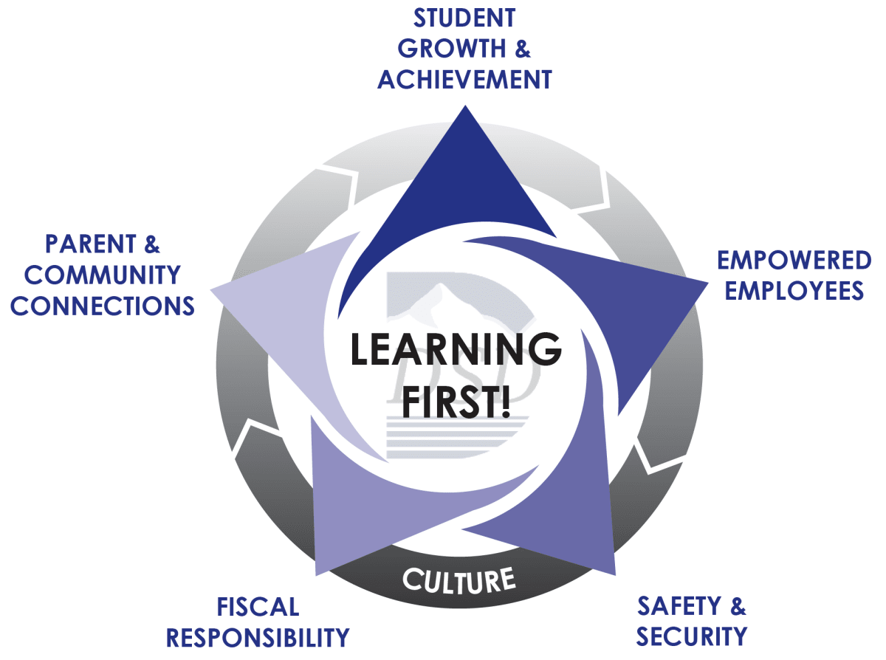

Heritage Elementary is committed to supporting the District Strategic Plan. We value Student Growth and Achievement, Empowered Employees, Safety and Security, Fiscal Responsibility, and Parent and Community Connections. At Heritage Elementary Learning First is our priority.

TECHNOLOGY/INTERNET ACCESS/COMPUTERS
Students must sign an Acceptable Use Agreement form to have access to the technology in our building. The Acceptable Use Agreement form is on file in the office. Computers are available for student use in the Media Center, classrooms and the computer lab. Information that is saved on the computers is protected by individual passwords. Violation of the computer Acceptable Use Agreement will be reviewed by the technology committee and consequences imposed.

TELEPHONES
Telephone Use & Student Messages The telephone is an essential instrument of school operations. Therefore, we ask that students only use the telephone with teacher approval if they need to contact parents for illness or emergencies. Please help us by reminding your students that if they call home from the school during the day and do not reach you, they should leave you a message. Many parents see the school phone number on caller ID and call the school to find out ‘why we were calling.’ Many times, we are unable to give you an answer, because EVERY PHONE in the building will show as 801-402-1200 on your caller ID. The office has no way to determine where a phone call originates.

Students will not be allowed to call home to arrange an after-school play date. Please set this up before school or after your student arrives home.

Calling the school with messages for students:
It is important that you plan in the morning before school with your children as to whom they are riding or walking home with at the end of the school day. Office personnel are not available to run messages into classrooms. Calling into classrooms is also extremely disruptive and discouraged. Teachers are not expected to stop teaching and answer their phones during teaching hours. Please be aware that if you call to leave a message for your student, there is a chance that the message won’t reach them in a timely manner. Understand that relaying messages is not the responsibility of school staff, so again, please make all after school arrangements in the morning before your students leave.

Calling the school with messages for teachers:
Please be aware that teachers are not expected to stop teaching and answer their phones during teaching hours. While teachers are always open to communication with parents, phone calls during the school day are disruptive to the teaching process, so please limit calls accordingly. If you have left messages on teachers’ phones, and they have not yet responded, it means that they are busy educating your students, or out of the classroom. Please do not make repeated phone calls, as your message will not reach them any quicker. Many teachers may respond faster to emails.

Each teacher has a phone in his or her room. Teachers are encouraged to give parents their classroom phone number. Teachers should turn the phone ringer down to limit interruption during class instruction. Parents will be allowed to leave a message that can be returned at the teacher’s convenience. Students may use classroom phones to call their home when necessary. We ask that parents make after school plans with their children before school begins – thus limiting the need to contact students during the day. After school, if a child wishes to use the phone, he or she may do so with teacher permission. Teachers should not send students to the office to use the office phone. Students should use classroom phones.

TOYS and electronic games
Toys, stuffed animals, electric games, cards, etc. are not allowed at school. Cosmetics including make-up, nail polish, perfume, etc., are also discouraged. These and similar items disrupt learning. Some of these games are highly sought after and are sometimes stolen. The school will not be responsible for the cost of stolen electronic games, nor will the school be expected to expend time, energy and resources trying to recover stolen electronic items and apply consequences to the guilty party.

If a student chooses to bring his own ball or other playground equipment to school, we will not be liable for any lost or stolen item. If it becomes a nuisance, the playground duties will have the right to remove the item from the child and ask them not to bring it again. Teachers may confiscate any nuisance item and will return it only to the parent. Heritage Elementary cannot be responsible for any lost or stolen items.

TREATS
We are encouraging the use of non-food treats for rewards and/or classroom treats. This is especially important considering the increasing number of students with food allergies or special dietary needs. If food is brought into the classroom, it is required that you bring commercially prepared food items. Peanut products are strongly discouraged due to students having nut allergies. Please check with the classroom teacher regarding students who may have special dietary needs or allergies. Sharing a fun book or activity with the class would be a great way to spotlight your child on their special days.

VANDALISM
Fines will be assessed for damages and violators will be referred to the proper authorities.

VOLUNTEERS AND VISITORS
Parents are always welcome to visit the school. Planned visits are best. If you wish to conference with a teacher, please make an appointment. Unscheduled conferences are strongly discouraged as they disrupt the instructional day of all students in the class. Visitors please check-in at the office and receive a visitor identification badge before proceeding to classrooms.

THANK YOU for taking the time to read and discuss this policy manual with your family. It is our goal to provide open communication with parents and maintain a positive educational experience for all our students at Heritage Elementary!

